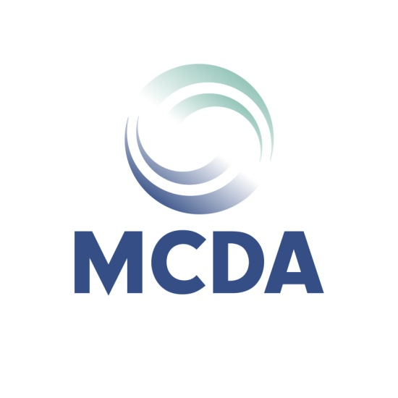
2020 Minnesota Careers Conference
Presented Jointly by Minnesota Career Development Association and Normandale Community College GCDF
On March 13, 2020
At Normandale, Community College, Bloomington, Minnesota
Contact Person: |  |  |  |  | Phone Number:
Organization Address: |  |  |  |  | E-mail Address:
We have agreed to: |  | ☐ Platinum ($800)
 |  | ☐ Gold ($600)
☐ Silver ($400)
☐ Bronze ($200)

☐ Please reserve on 3’ x 6’ exhibitor table with skirt and # of chairs. (Not an option for Bronze
Sponsorship level)
Please note: Exhibitors are responsible for table signage.
Equipment
Electrical services are available at no charge; all other services require a fee for service. Do you have needs other than electrical? If so, please describe: .
Representative Registration Information
The MCDA Conference Planning Committee needs to register all representatives exhibiting at the conference. Please provide the full names and email addresses of each representative.
Representative #1
(Platinum, Gold, & Silver Levels)
Representative #2
(Platinum & Gold Levels)
Representative #3
(Platinum Level)
Please return this completed form along with your check payable to
Minnesota Career Development Association by February 14, 2020 THANK YOU!!

Mail to: MCDA Sponsorship  Gordon Helle  PO Box 3421  Minneapolis, MN 55403 |  |  |  | gwhelle@gmail.com  847-387-7866  (can pay by phone via Credit Card)

