The Path of Mastery: How to Find Purpose, Passion, and Prosperity in Your Career
Resources

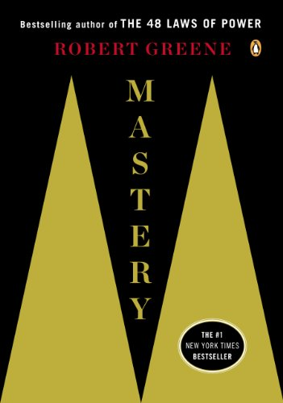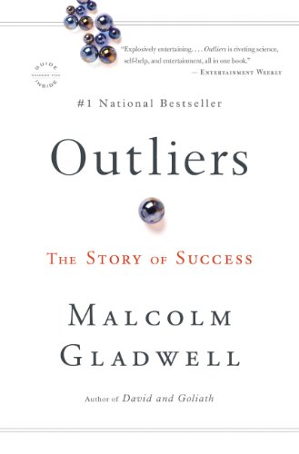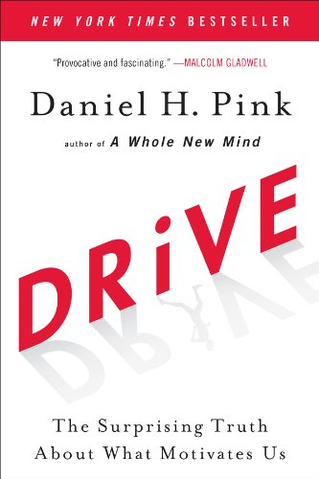

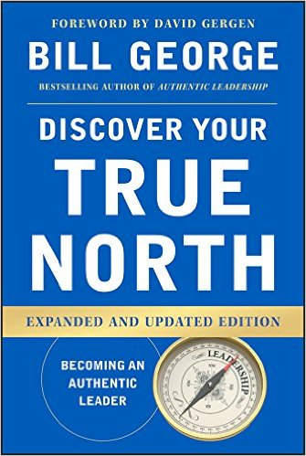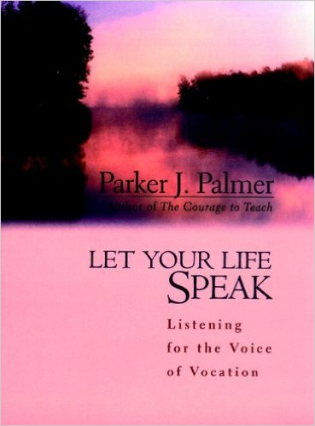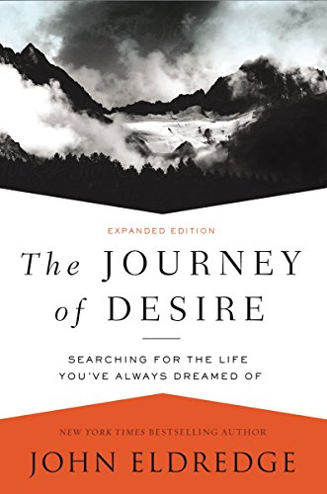

Online Resources

http://www.gifcounseling.com/my-library/
www.couragerenewal.org/parker
https://onbeing.org/author/parker-j-palmer/
https://www.forbes.com/sites/danschawbel/2012/11/13/robert-greene-how-to-become-the-master-of-any-skill/#3b5a597b1a23
https://www.ted.com/talks/dan_pink_on_motivation
http://gladwell.com/outliers/
https://www.ted.com/speakers/malcolm_gladwell
https://www.goodreads.com/work/quotes/266316-the-journey-of-desire-searching-for-the-life-we-ve-only-dreamed-of
http://www.billgeorge.org/page/true-north

